A.PREETIKA
192371073
LAB EXPERIMENTS

DDL Commands – CREATE, ALTER, DROP
AIM:
To Create, Alter, Drop, Rename, Truncate using Data Definition Language (DDL) statements.
Description:
Data Definition Language (DDL) statements are used to define the database structure or schema.
DDL Commands: Create, Alter, Drop, Rename, Truncate
CREATE:
CREATE DATABASE house_plotting;
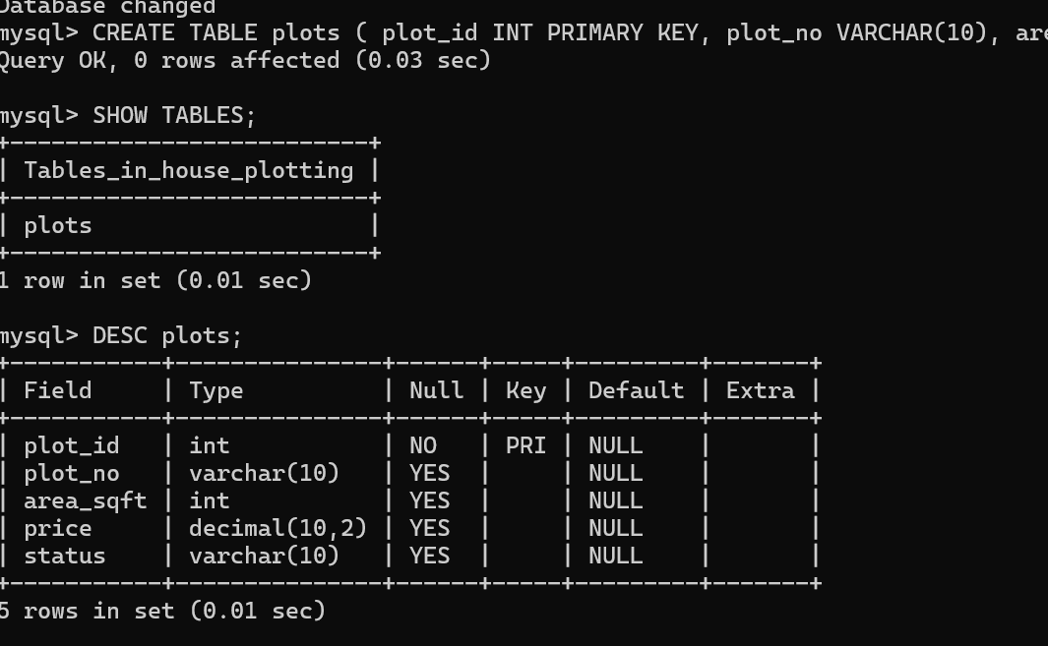

ALTER: - alters the structure of the database
ALTER TABLE plots ADD location VARCHAR(20);
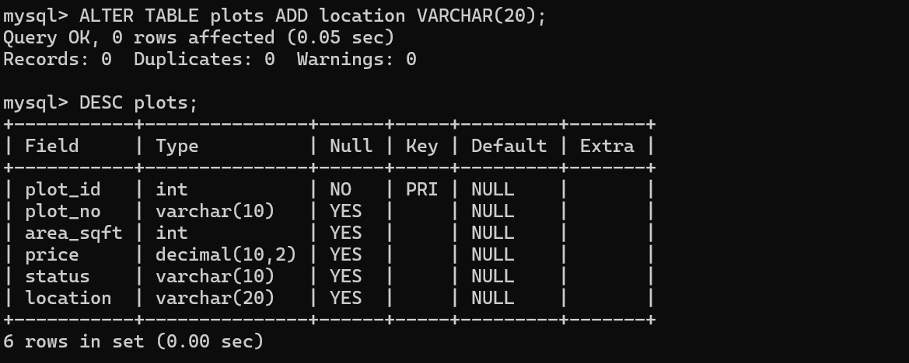

DROP:
ALTER TABLE PLOTS DROP COLUMN OwnerName;
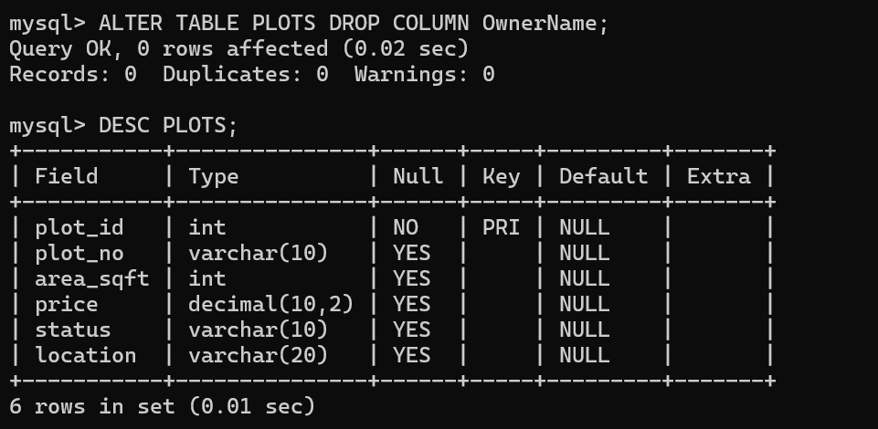

TRUNCATE:
TRUNCATE TABLE plots;
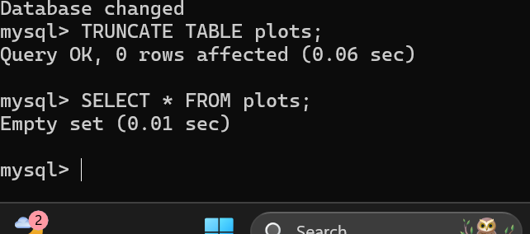

RENAME:
RENAME TABLE HOUSE_PLOTS TO PLOTS;
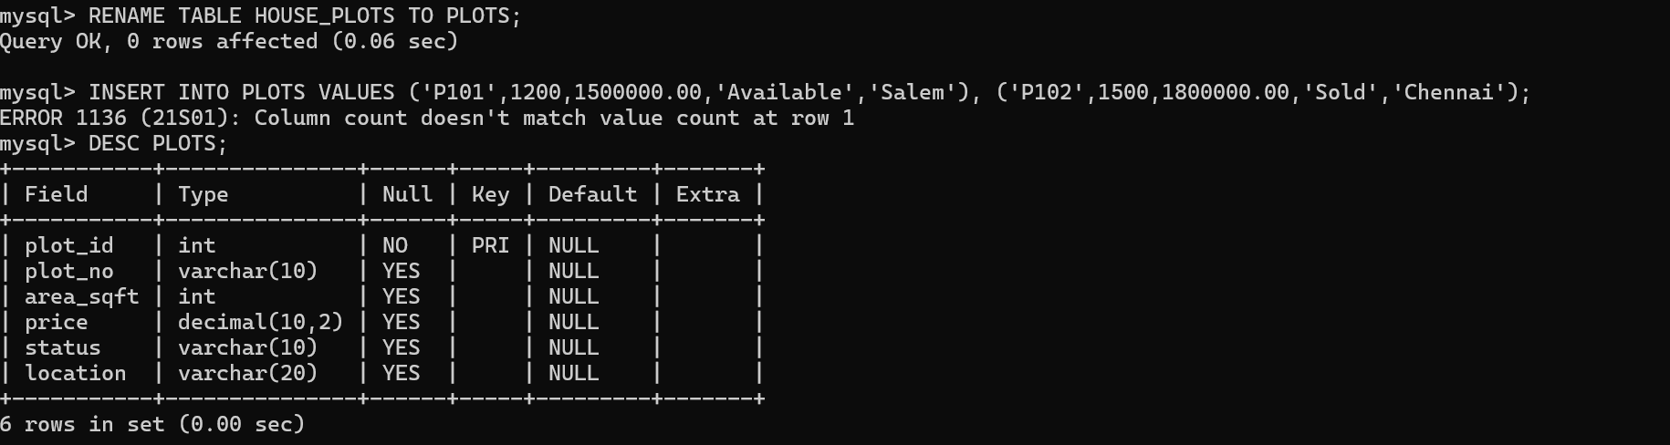

RESULT:
Tables are created, altered and modified using DDL commands.

2. DDL Commands with Constraints – PRIMARY, FOREIGN KEY, UNIQUE, CHECK
AIM:
To add the constraints like primary key, foreign key, unique key and check using DDL commands.
Description:
PRIMARY KEY:
The PRIMARY KEY constraint uniquely identifies each record in a database table.
Primary keys must contain UNIQUE values, and cannot contain NULL values.
A table can have only one primary key, which may consist of single or multiple fields.

FOREIGN KEY:
➢ A FOREIGN KEY is a key used to link two tables together.
➢ A FOREIGN KEY is a field (or collection of fields) in one table that refers to the
PRIMARY KEY in another table.
➢ The table containing the foreign key is called the child table, and the table containing the candidate key is
called the referenced or parent table.
UNIQUE Constraint:
➢ The UNIQUE constraint ensures that all values in a column are different.
➢ Both the UNIQUE and PRIMARY KEY constraints provide a guarantee for uniqueness for a column
or set of columns.
➢ A PRIMARY KEY constraint automatically has a UNIQUE constraint.
➢ However, you can have many UNIQUE constraints per table, but only one PRIMARY KEY
constraint per table.

CHECK Constraint:
➢ The CHECK constraint is used to limit the value range that can be placed in a column
➢ If you define a CHECK constraint on a single column it allows only certain values for this column.
➢ If you define a CHECK constraint on a table it can limit the values in certain columns based on
values in other columns in the row.
PRIMARY:
ALTER TABLE table_name
ADD PRIMARY KEY(primary_key_column);

FOREIGN KEY:
ALTER TABLE table_name
ADD CONSTRAINT constraint_name
FOREIGN KEY foreign_key_name (columns)
REFERENCES parent_table(columns)
ON DELETE action
ON UPDATE action
UNIQUE:
CREATE TABLE table_1(
...
column_name_1 data_type,
...
UNIQUE(column_name_1)
);
CHECK
CREATE TABLE IF NOT EXISTS parts (
part_no VARCHAR(18) PRIMARY KEY,
description VARCHAR(40),
cost DECIMAL(10 , 2 ) NOT NULL CHECK(cost > 0), price DECIMAL (10,2) NOT
NULL
);
Questions:
- Add PRIMARY KEY to PLOTS
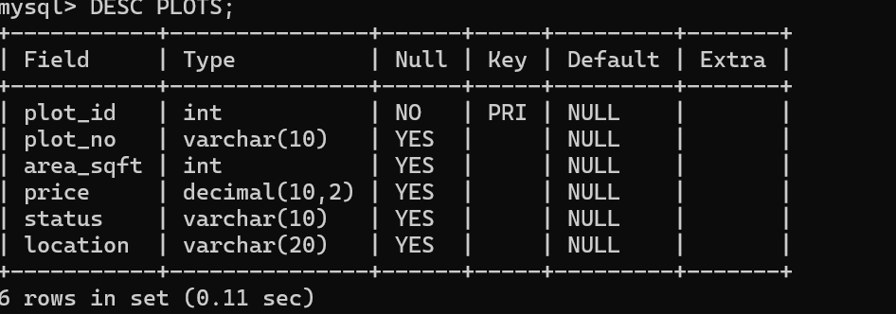

2) Alter the table name with following structure.
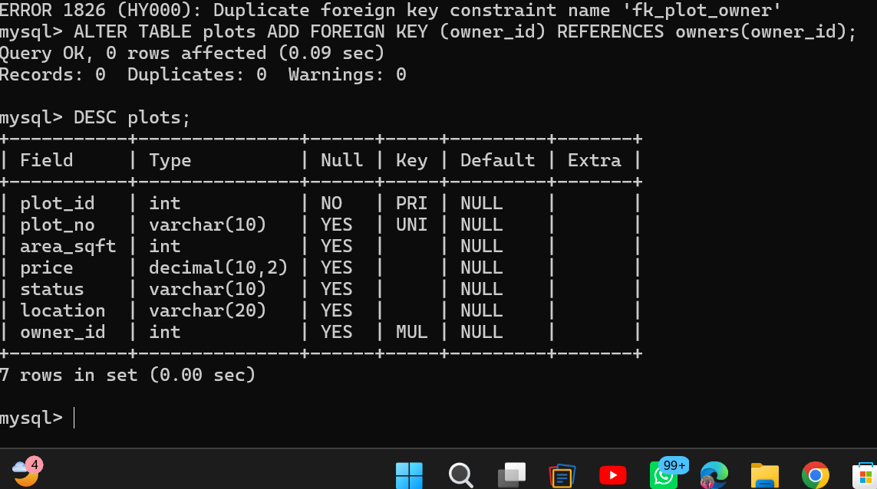

3.Add a UNIQUE constraint to plot_no.

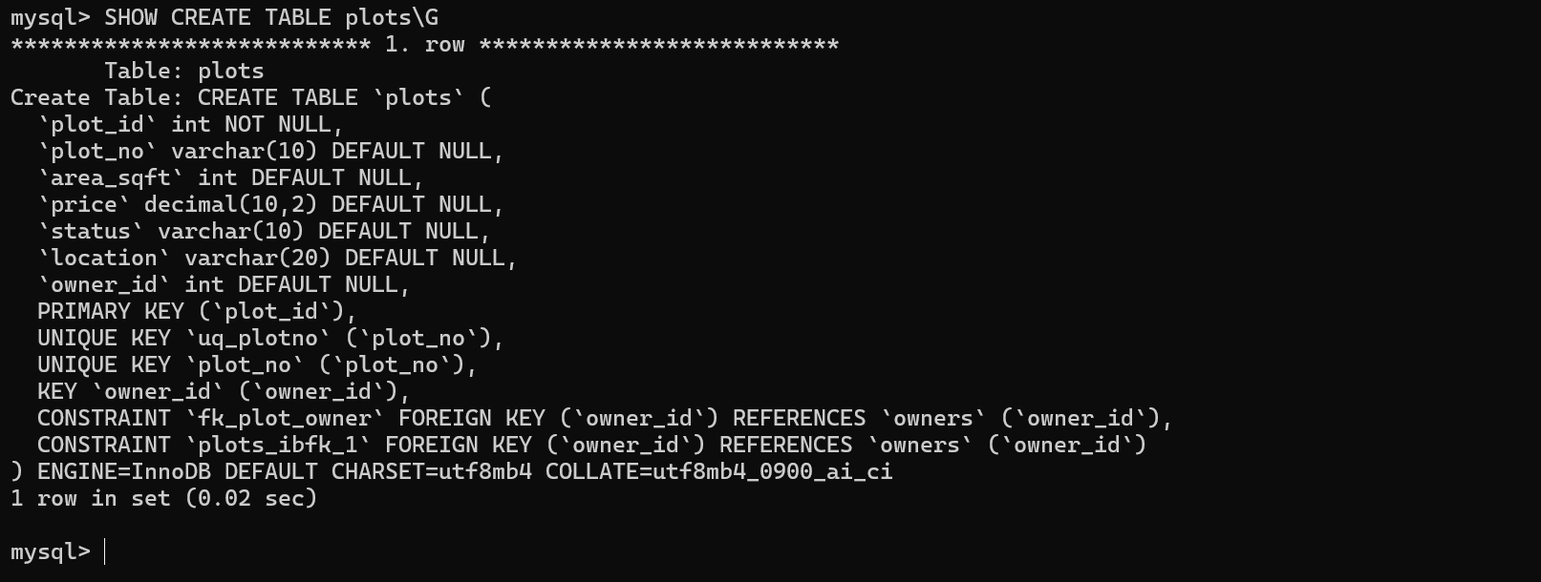

4. FOREIGN KEY
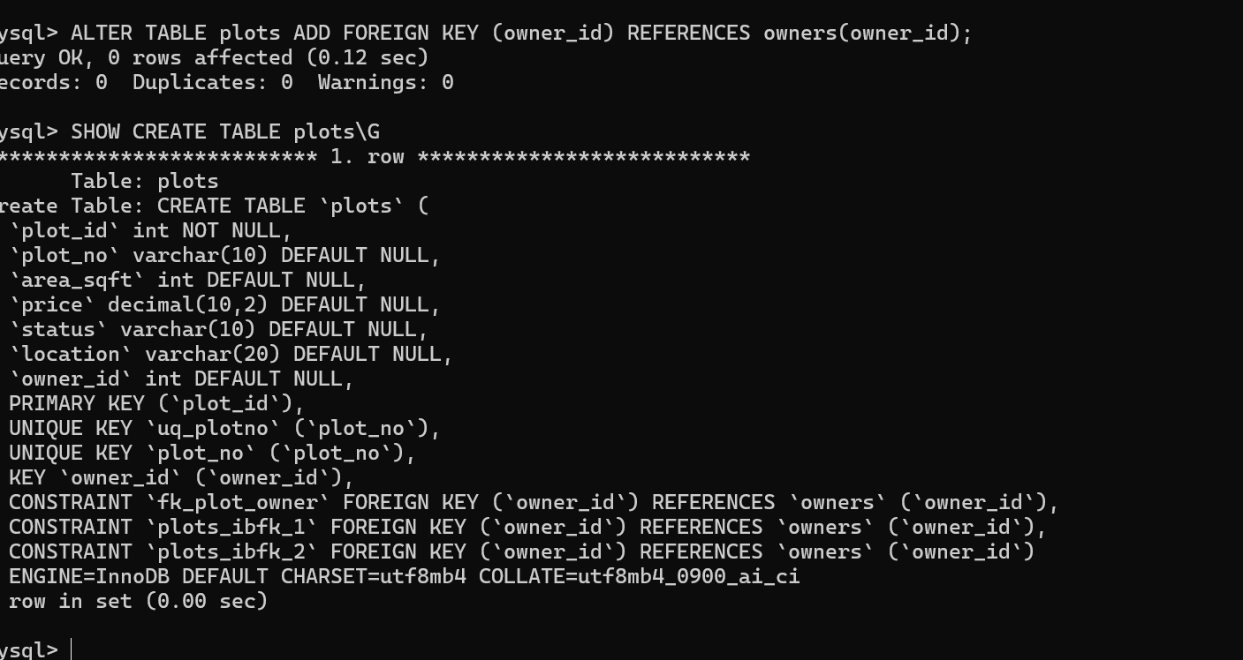

3.DML Commands – INSERT, SELECT
Aim:
To perform Data Manipulation Language (DML) Commands such as INSERT, SELECT in the table.

Description:
Data Manipulation Language (DML) statements are used for managing data within schema objects. DML
Commands: Insert, Select
➢ INSERT - insert data into a table
➢ SELECT - retrieve data from the a database
INSERT:
INSERT INTO table_name
VALUES (value1, value2, value3,...);
( or )
INSERT INTO table_name (column1, column2, column3,...)
VALUES (value1, value2, value3,...);

SELECT:
SELECT column_name(s)
FROM table_name;

Questions:
1. Populate all the five tables with your own data.
2. View all the records from the five tables.

OUTPUT:
Table 1: PLOTS
INSERT INTO plots VALUES (1,'P101',1200,1500000.00,'Available','Salem',1), (2,'P102',1500,1800000.00,'Sold','Chennai',2), (3,'P103',1000,1300000.00,'Available','Erode',1);
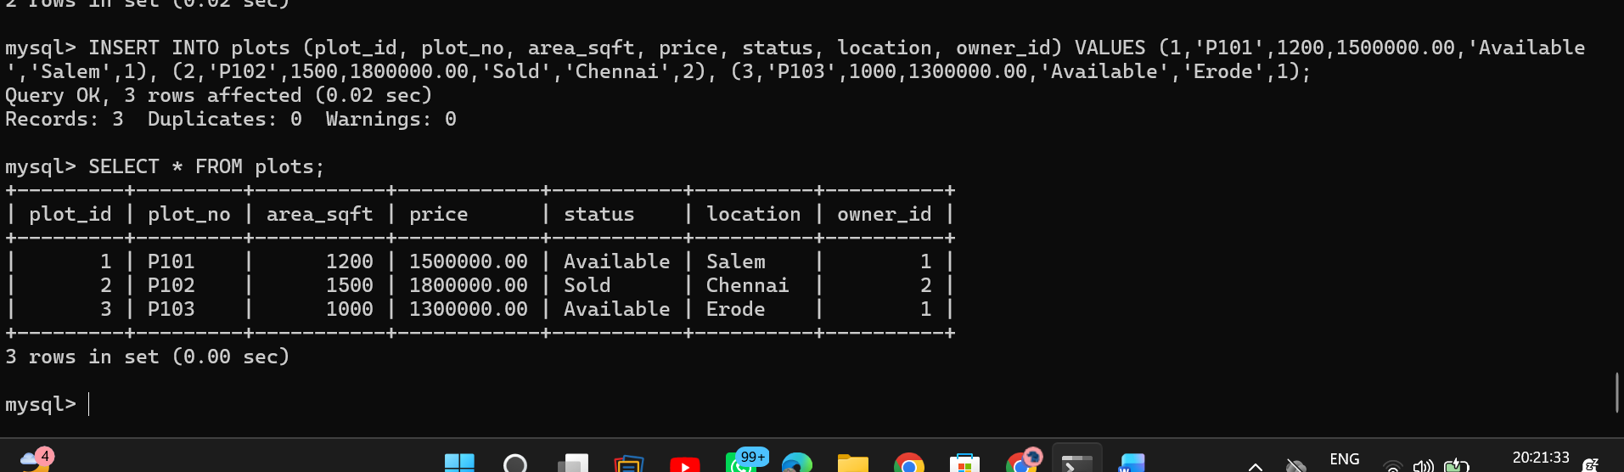

Question 2: View all the records from the five tables.
SELECT * FROM owners; SELECT * FROM plots;
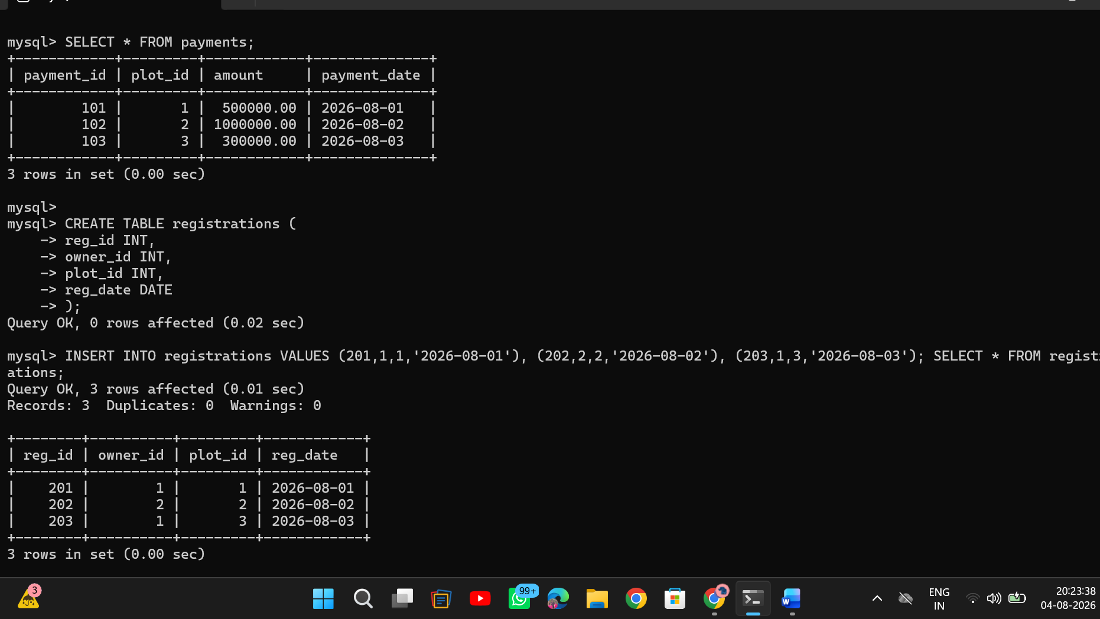
RESULT:
Data Manipulation Language (DML) Commands such as INSERT, SELECT are performed in the five tables.

4. DML Commands with Constraints (UPDATE, DELETE)

To perform Data Manipulation Language (DML) Commands such as UPDATE, DELETE in the table. Description:
Data Manipulation Language (DML) statements are used for managing data within schema objects. DML Commands: Update, Delete
➢ UPDATE - updates existing data within a table
➢ DELETE - deletes all records from a table, the space for the records remain

UPDATE:
UPDATE table_name
SET column1=value, column2=value2,...
WHERE some_column=some_value;
DELETE:
DELETE FROM table_name
WHERE some_column=some_value;
Questions:
1. Update the value
2. Delete the record
3. Modify the age
4. Remove all

OUTPUTS:

1) Update the owner name whose owner_id is 1
UPDATE owners SET owner_name = 'Arun Prakash' WHERE owner_id = 1;
Check:
SELECT * FROM owners;
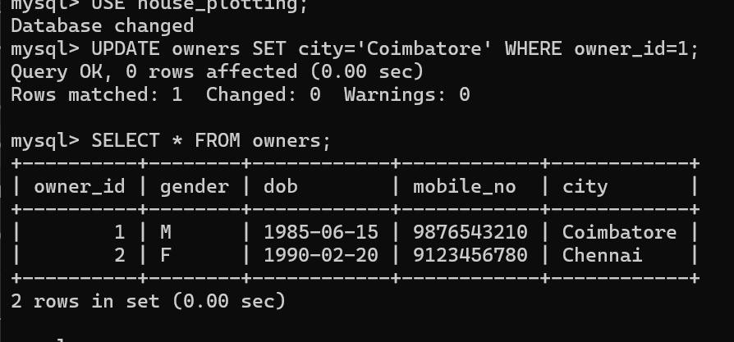
2. Delete owner with id 3:
DELETE FROM owners WHERE owner_id=3;
Check:
SELECT * FROM owners;
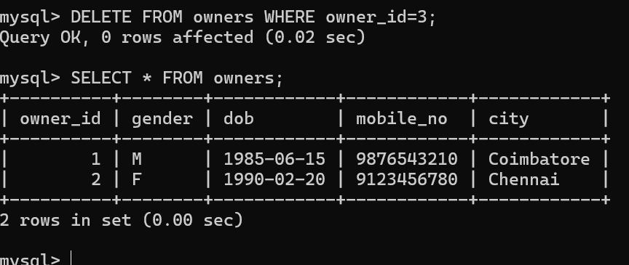
3. UPDATE plots
UPDATE plots SET price=1900000.00 WHERE plot_no='P102';
Check:
SELECT * FROM plots;

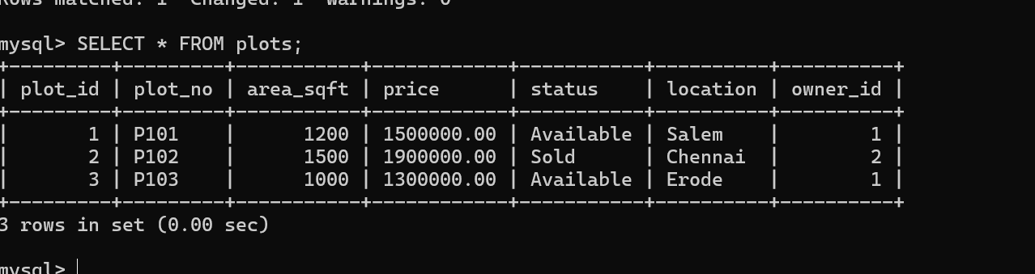

4. DELETE plots
DELETE FROM plots WHERE area_sqft > 1400;
Check:
SELECT * FROM plots;
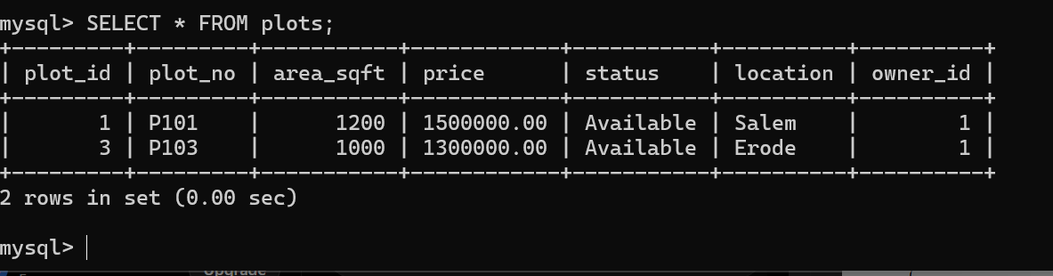
RESULT:
Data Manipulation Language (DML) Commands such as UPDATE, DELETE are performed in the five tables.

5. AIM:
SELECT with various clause – WHERE, pattern matching
To view the records from the tables using SELECT commands with WHERE Clause and Pattern matching.
DESCRIPTION:
The SELECT statement allows you to get the data from tables. A table consists of rows and columns like a spreadsheet. Often, you want to see a subset rows, a subset of columns, or a combination of two. The result of the SELECT statement is called a result set that is a list of rows, each consisting of the same number of columns.
SELECT:
SELECTcolumn_1, column_2, ...
FROMtable_1
[INNER | LEFT |RIGHT] JOIN table_2 ON conditions
WHEREconditions
GROUP BY column_1
HAVING group_conditions
ORDER BY column_1
LIMIT offset, length;
The SELECT statement consists of several clauses as explained in the following list:
➢ SELECT followed by a list of comma-separated columns or an asterisk (*)
to indicate that you want to return all columns.
➢ FROM specifies the table or view where you want to query the data.
➢ JOIN gets related data from other tables based on specific join conditions.
➢ WHERE clause filters row in the result set.
➢ GROUP BY clause groups a set of rows into groups and applies aggregate
functions on each group.
➢ HAVING clause filters group based on groups defined by GROUP BY clause.
➢ ORDER BY clause specifies a list of columns for sorting.
➢ LIMIT constrains the number of returned rows.
LIKE:
➢ The LIKE operator is commonly used to select data based on patterns. Using the LIKE operator in the right way is essential to increase the query performance.
➢ The LIKE operator allows you to select data from a table based on a specified pattern. Therefore, the LIKE operator is often used in the WHERE clause of the SELECT statement.
➢ MySQL provides two wildcard characters for using with the LIKE operator, the percentage % and underscore _ .
➢ The percentage ( % ) wildcard allows you to match any string of zero or more characters. ➢ The underscore ( _ ) wildcard allows you to match any single character.
Questions:
WHERE:
1. The student counselor wanted to display the registration number, student name and date of birth for all the students.
2. The controller of examinations wanted to list all the female students
3. List the Students who registered for the “C001” course.
4. Display all faculty details joined before “November 2014”
5. Display all the courses not allotted to hall ‘H001’
LIKE:
6. List the students whose name ends with the substring “sh”
7. Display all students whose name contains the substring “sh”
8. Find all the students who are located in cities having “Sal” as substring
9. Display the students whose names do not contain six letters.
10. Find all the students whose names contains “am”.
OUTPUTS:
1. Display owner_id, city and dob of all owners
SELECT owner_id, city, dob FROM owners;

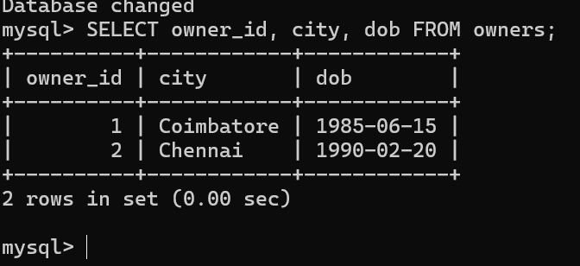
2. List all female owners
SELECT * FROM owners WHERE gender='F';
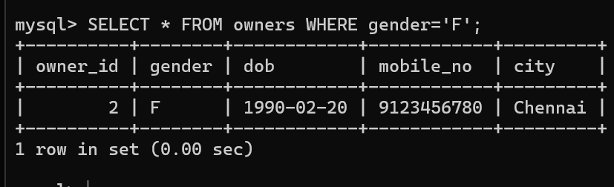

3. List plots that are available
SELECT * FROM plots WHERE status='Available';
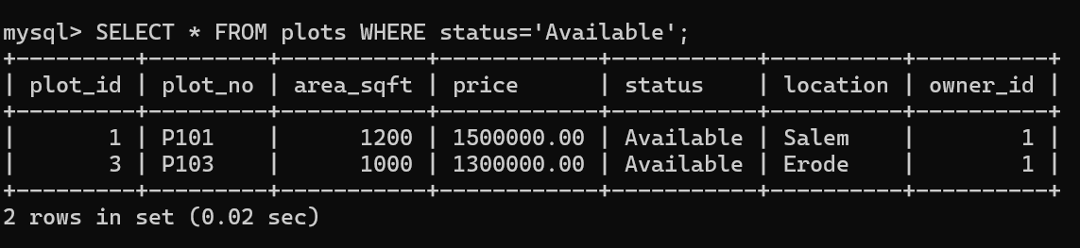

4. Display plots located in Salem
SELECT * FROM plots WHERE location='Salem';
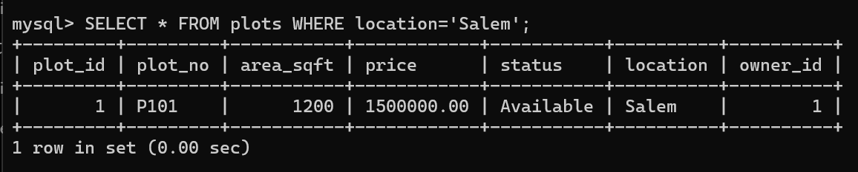

5. Display plots not located in Chennai
SELECT * FROM plots WHERE location <> 'Chennai';
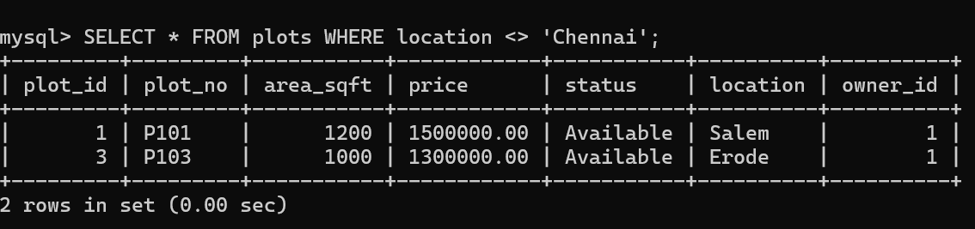

LIKE (Pattern Matching)

6. Owners whose city ends with "em"
SELECT * FROM owners WHERE city LIKE '%em';

7. Owners whose city contains "en"
SELECT * FROM owners WHERE city LIKE '%en%';
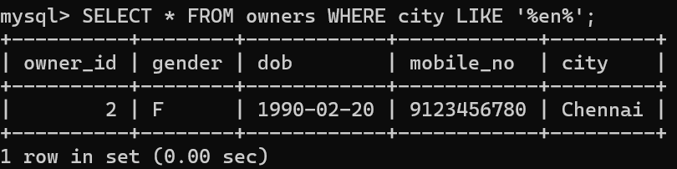

8. Plots whose location contains "ro"
SELECT * FROM plots WHERE location LIKE '%ro%';
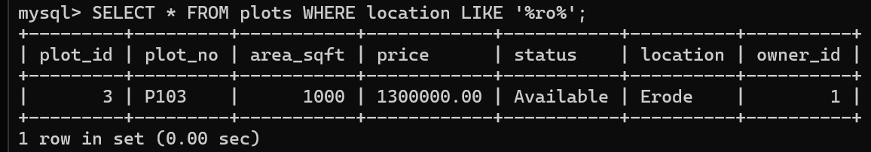

9. Cities having exactly 5 letters
SELECT * FROM owners WHERE city LIKE '_____';

10. Plot numbers containing "10"
SELECT * FROM plots WHERE plot_no LIKE '%10%';
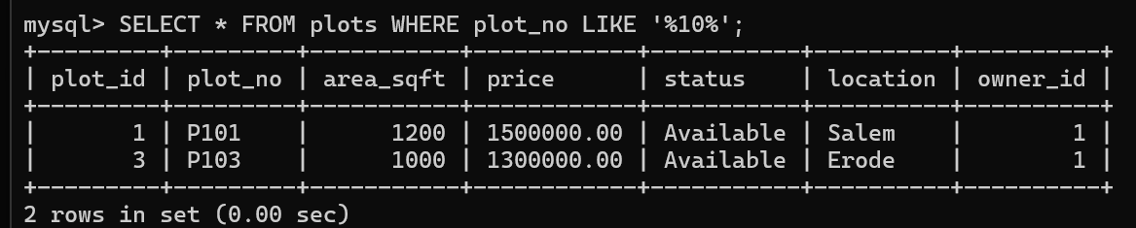

RESULT:
The records from the tables are displayed using SELECT commands with WHERE Clause and Pattern matching.

Ex. No. : 6
SELECT with various clause – BETWEEN, IN, Aggregate function

AIM:
To view the records from the tables using SELECT commands with BETWEEN, IN, Aggregate functions.
DESCRIPTION:
➢ The BETWEEN operator allows you to specify a range to test. We often use the BETWEEN operator in the WHERE clause of the SELECT, INSERT, UPDATE, and DELETE statements.
➢ The IN operator allows you to determine if a specified value matches any one of a list or a sub query. ➢ MySQL provides many aggregate functions that include AVG, COUNT, SUM, MIN, MAX, etc. An aggregate function ignores NULL values when it performs calculation except for the COUNT function.
BETWEEN operator:
SELECTcolumn1,column2,...
FROMtable_name
WHERE expr [NOT] BETWEEN begin_expr AND end_expr;
IN operator:
SELECTcolumn1,column2,...
FROMtable_name
WHERE (expr|column_1) IN ('value1','value2',...);
Questions:
IN & BETWEEN
1. List the type of the courses “Statistics” and “Programming”
2. The instructor wants to know the CourseNos whose scores are in the range 50 to 80
AGGREGATE
1. Find the average mark of “C002”.
2. List the maximum, minimum mark for “C002”
3. List the maximum, minimum, average mark for each course
4. List the name of the courses and average mark of each course.
5. Calculate the sum of all the scores.
6. How many students are registered for each course? Display the course description and the number of students registered in each course.
7. How many courses did each student register for?

OUTPUTS:
IN & BETWEEN
1. List plots located in Salem and Chennai
SELECT plot_no, location FROM plots WHERE location IN ('Salem','Chennai');
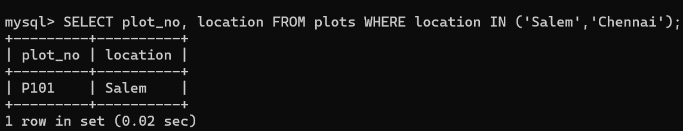

BETWEEN Operator

2. List plots whose price is between 13,00,000 and 18,00,000
SELECT plot_no, price FROM plots WHERE price BETWEEN 1300000 AND 1800000;
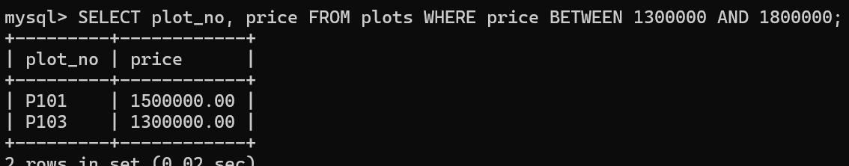

Aggregate Functions
1. Find the average plot price
SELECT AVG(price) AS average_price FROM plots;
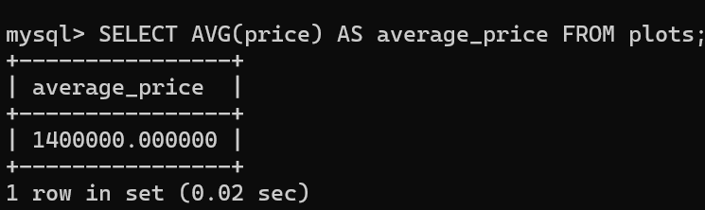

2. Find maximum and minimum plot price
SELECT MAX(price) AS maximum_price, MIN(price) AS minimum_price FROM plots;
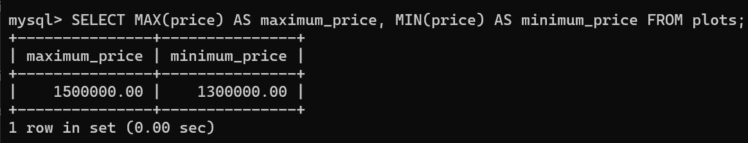

3. Find maximum, minimum and average area
SELECT MAX(area_sqft) AS maximum_area, MIN(area_sqft) AS minimum_area, AVG(area_sqft) AS average_area FROM plots;
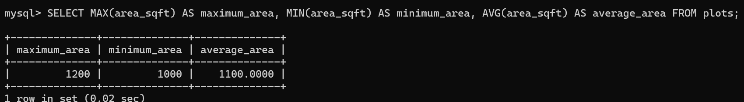

4. Display location and average plot price for each location
SELECT location, AVG(price) AS average_price FROM plots GROUP BY location;
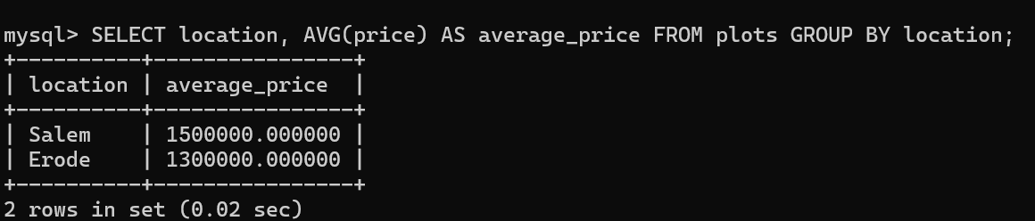

5. Calculate total amount received in payments
SELECT SUM(amount) AS total_payment FROM payments;
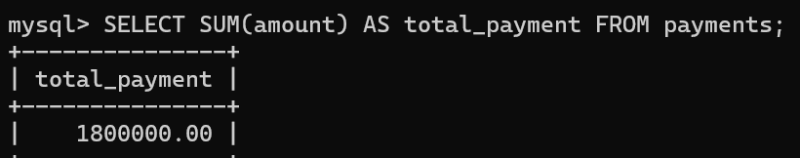

6. Count number of plots in each location
SELECT location, COUNT(*) AS total_plots FROM plots GROUP BY location;
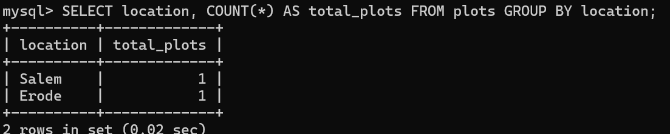

7. Count how many plots each owner has
SELECT owner_id, COUNT(*) AS total_plots FROM plots GROUP BY owner_id;
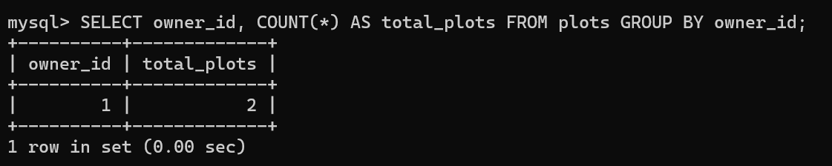

RESULT:
The records from the tables are displayed using SELECT commands with WHERE Clause and Pattern matching.

Ex. No.: 7
SELECT with GROUP BY, HAVING, ORDER BY
AIM:
To view the records from the tables using SELECT commands with Group By, Having, Order By
DESCRIPTION:
GROUP BY – HAVING:
➢ The GROUP BY clause groups a set of rows into a set of summary rows by values of columns or expressions. The GROUP BY clause returns one row for each group. In other words, it reduces the number of rows in the result set.
➢ The GROUP BY clause is used with aggregate functions such as SUM, AVG, MAX, MIN, and COUNT. The aggregate function that appears in the SELECT clause provides the information about each group. ➢ The GROUP BY clause is an optional clause of the SELECT statement.
➢ To filter the groups returned by GROUP BY clause, you use a HAVING clause.
SYNTAX:
GROUP BY – HAVING:
SELECTc1, c2,...,cn, aggregate_function(ci)
FROMtable
WHEREwhere_conditions
GROUP BYc1 , c2,...,cn
HAVINGconditionS
ORDER BY:
SELECT column1, column2,...
FROMtbl
ORDER BY column1 [ASC|DESC], column2 [ASC|DESC],...

GROUP BY & HAVING:
1. How many plots are available in each location?
SELECT location, COUNT(*) AS total_plots FROM plots GROUP BY location;
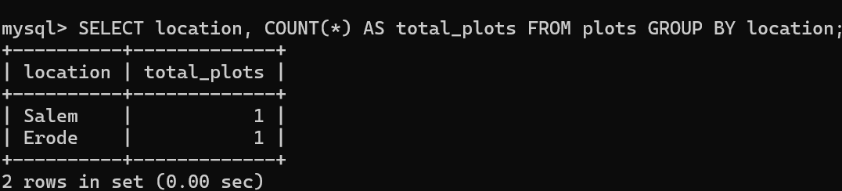

2. How many plots does each owner have?
SELECT owner_id, COUNT(*) AS total_plots FROM plots GROUP BY owner_id;
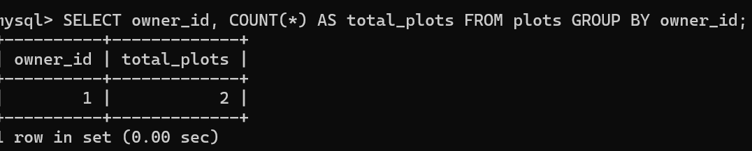

ORDER BY

3. Display plot number, status and location in ascending order of plot_id
SELECT plot_no, status, location FROM plots ORDER BY plot_id ASC;

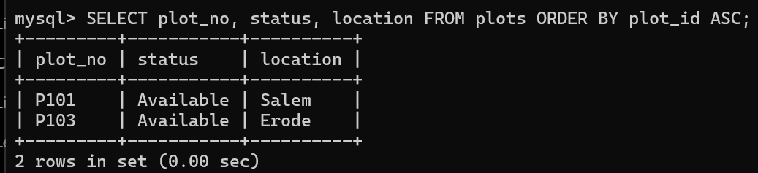

4. Display plots in the order of highest price first
SELECT * FROM plots ORDER BY price DESC;
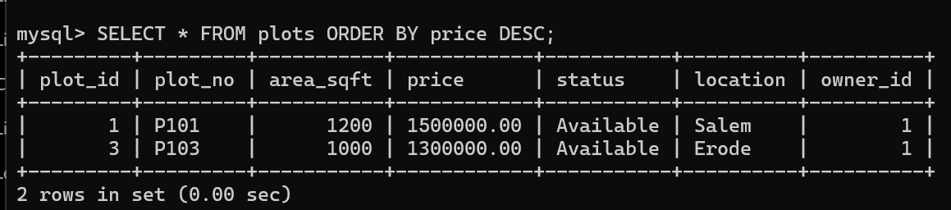

RESULT:
The records from the tables are displayed using SELECT commands with GROUP BY, HAVING and ORDER BY.

Ex. No.: 8
Query with Sub Query & Correlated Query

Aim:
To perform subquery and correlated query on the given relations.

DESCRIPTION:
SUBQUERY
A MySQL subquery is a query nested within another query such as SELECT, INSERT, UPDATE or DELETE. In addition, a MySQL subquery can be nested inside another subquery.
A MySQL subquery is called an inner query while the query that contains the subquery is called an outer query. A subquery can be used anywhere that expression is used and must be closed in parentheses.
CORRELATED QUERY:
A correlated subquery is a subquery that uses the data from the outer query. In other words, a correlated subquery depends on the outer query. A correlated subquery is evaluated once for each row in the outer query.
SYNTAX:
SUBQUERY: SELECTc1, c2,...,cn
FROMtable
WHEREc1 IN (SELECTc1, c2,...,cn
FROMtable
WHEREwhere_conditions);
CORRELATED QUERY:
SELECT*
FROMtable_name
WHEREEXISTS (subquery );

Questions:

Sub-Query and Correlated Sub-Query:
1. Which of the student’s score is greater than the average score?
2. Which of the students’ have written more than one assessment test?
3. Which faculty has joined recently and when?
4. List the course and score of assessments that have the value more than the average score each Course.

OUTPUTS:
1. Which plots have price greater than the average price?
SELECT plot_no, price FROM plots WHERE price > (SELECT AVG(price) FROM plots);
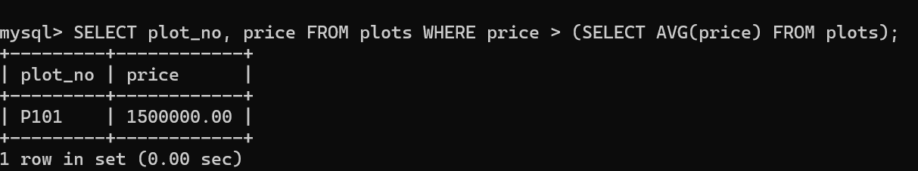

2. Which owners have purchased more than one plot?
SELECT owner_id FROM plots GROUP BY owner_id HAVING COUNT(*) > 1;

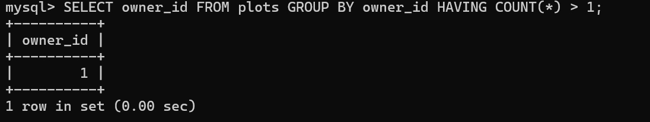

3. Which owner registered most recently and when?
SELECT owner_id, reg_date FROM registrations WHERE reg_date = (SELECT MAX(reg_date) FROM registrations);
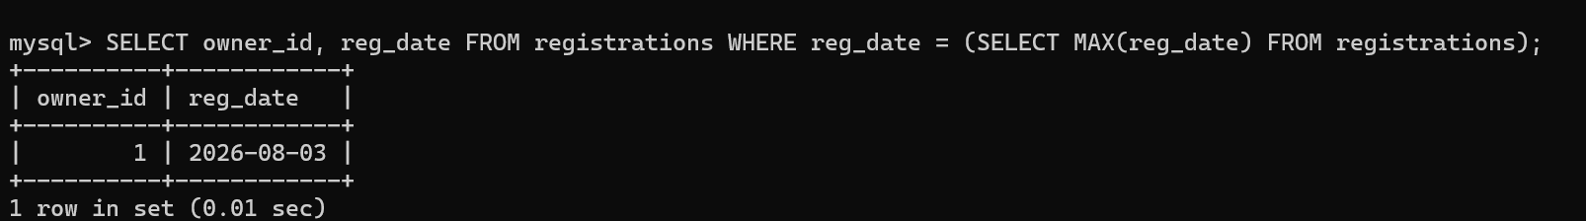
4. List plot and payment amount that are greater than the average payment amount for that plot (Correlated Query)
SELECT p1.plot_id, p1.amount FROM payments p1 WHERE p1.amount > ( SELECT AVG(p2.amount) FROM payments p2 WHERE p1.plot_id = p2.plot_id );

RESULT:
The records from the tables are displayed using Sub-Query and Correlated Sub-Query.

Ex. No.: 9
Query with Joins – EquiJoin, InnerJoin, OuterJoin
AIM: To perform JOIN using Equi Join, Inner Join, Outer Join on the given relation.
DESCRIPTION:
JOIN
A MySQL join is a method of linking data from one or more table based on values of the common column between tables.
MySQL supports the following types of joins:
1. Cross join
2. Inner join
3. Left join
4. Right join
CROSS JOIN
The CROSS JOIN makes a Cartesian product of rows from multiple tables. Suppose, you join t1 and t2 tables using the CROSS JOIN, the result set will include the combinations of rows from the t1 table with the rows in the t2 table.
CROSS JOIN:
SELECTt1.id, t2.id
FROMt1CROSS JOIN t2;
INNER JOIN:
SELECTt1.id, t2.id
FROMt1INNER JOINt2 ON t1.pattern = t2.pattern;
LEFT JOIN:
SELECTt1.id, t2.id
FROMt1LEFT JOINt2 ON t1.pattern = t2.pattern
ORDER BY t1.id;
RIGHT JOIN:
SELECTt1.id, t2.id
FROMt1RIGHT JOINt2 ON t1.pattern = t2.pattern
ORDER BYt2.id;

Questions:
1. List the departments where the faculty members are working.
2. Find the student who has no score in any of the courses. List student name and course number. 3. The office clerk needs the names of the courses taken by the faculty belonging to ‘ECE department’ whose name is ‘Kamal’

OUTPUTS:
1. List owners and the plots they own (INNER JOIN)
SELECT o.owner_id, o.city, p.plot_no, p.location FROM owners o INNER JOIN plots p ON o.owner_id = p.owner_id;

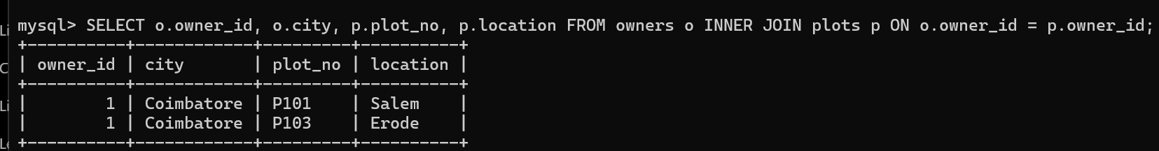

2. Find owners who have no plot (LEFT JOIN)
SELECT o.owner_id, o.city FROM owners o LEFT JOIN plots p ON o.owner_id = p.owner_id WHERE p.plot_id IS NULL;
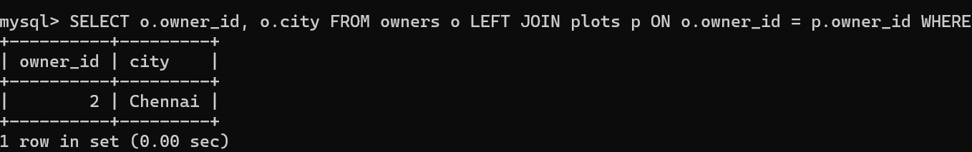

3. Display plot details with payment amount (INNER JOIN)
SELECT p.plot_no, p.location, pay.amount FROM plots p INNER JOIN payments pay ON p.plot_id = pay.plot_id;
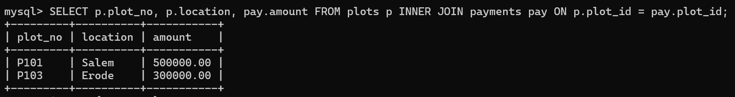

RESULT: The records from the tables are displayed using JOIN using EquiJoin, InnerJoin, OuterJoin.

Ex. No.: 10
AIM: To create view and index on the given relation.

DESCRIPTION:
VIEW:
MySQL has supported database views since version 5+. In MySQL, almost features of views conform to the SQL: 2003 standard. MySQL processes query against the views in two ways:
1.In a first way, MySQL creates a temporary table based on the view definition
2. Statement and executes the incoming query on this temporary table.
3.In a second way, MySQL combines the incoming query with the query defined the view into one query and executes the combined query.
SYNTAX- VIEW:
CREATE [ALGORITHM = {MERGE | TEMPTABLE | UNDEFINED}]
VIEW [database_name].[view_name]
AS [SELECT statement]

SYNTAX- INDEX:
CREATE [UNIQUE|FULLTEXT|SPATIAL] INDEXindex_name
USING [BTREE | HASH | RTREE]
ON table_name (column_name [(length)] [ASC | DESC],...)

Questions on View:
1. Create a view with plot number and price
CREATE VIEW v1 AS SELECT plot_no, price FROM plots;

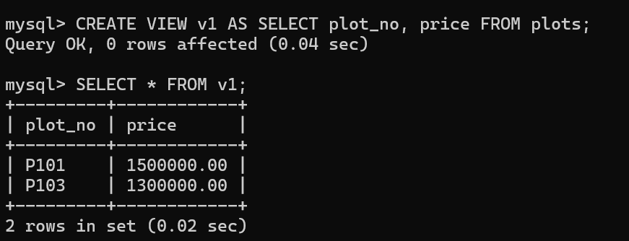

INDEX
1. Create an index on price
CREATE INDEX index1 ON plots(price);
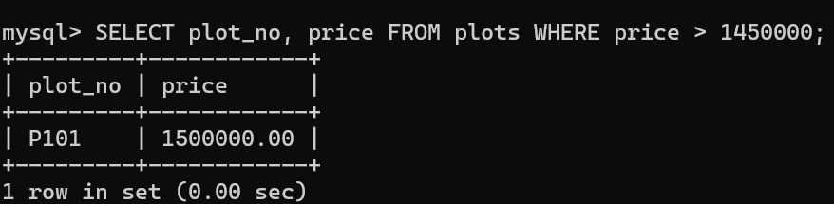

2. Display plot with plot_id = 1
SELECT plot_no, location FROM plots WHERE plot_id = 1;
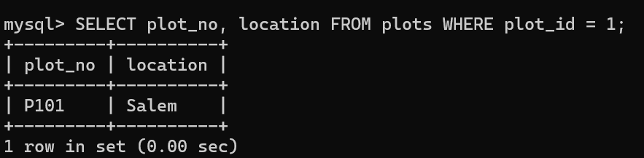

RESULT:
The records from the tables are displayed using view and index on the given relation.

